Experiment 9.3 Planck's constant
Type: Activity
Context:
In a Unit 2 experiment you may have measured the characteristics of a non-ohmic device, namely a light emitting diode (LED). The I/V characteristics of the diode showed a particular threshold voltage at which the LED began conducting. Different coloured LEDs are prepared by varying the varying the composition of the semiconductor material which results in transitions between different energy levels and hence emitted wavelengths.
Aim:
To determine the threshold voltage V_{t} of different coloured light emitting diodes and thereby determining Planck's constant..

Risk assessment/Safety:
Potential hazards | Hazard control measures
Electrical equipment can cause electric shocks or death | - Check that there are no exposed wires caused by loose fittings or from melted plastic insulation

Materials:
Power supply 0-12V DC
Ammeter (up to 100 mA)
Voltmeter (up to 1 V)
LEDs: Red (622 nm), yellow (589 nm), green (568 nm), blue (460 nm)
Fixed resistor 1 kΩ (any resistor between 700 Ω to 1 kΩ would suffice)
Rheostat (approximately 10 Ω or anything up to 100 Ω)
Connecting wires

Method:
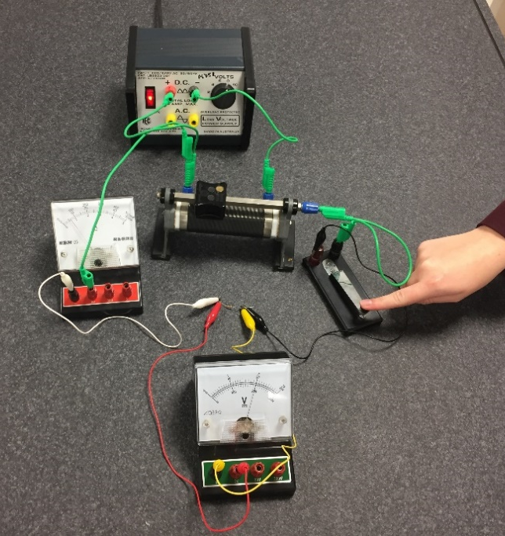

- Set up the circuit shown in the figure using the DC output of the laboratory power supply. The 1 kΩ resistor is there to protect the diode from overload and burning out. Any resistor between 700 Ω to 1 kΩ would suffice.
- Place the diode in the circuit as shown in Figure 3. This is called ‘forward bias’ when the silver end of the diode is connected to the negative side of the circuit.
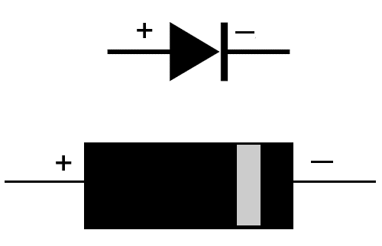 |  | 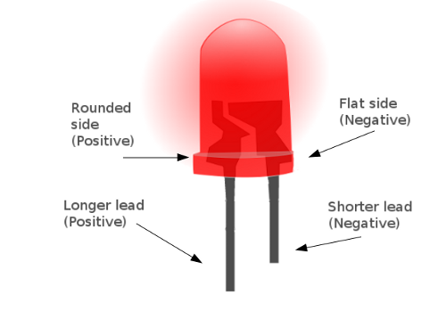
Silicon diode | Light emitting diode (LED)
- Connect the wires to the meters and select scales that will give suitable readings of up to 1V and 100 mA.
- Adjust the rheostat so the slider is close to the negative side. This will ensure a small voltage is delivered (‘impressed’) across the diode.
- Adjust the power supply to the 4 V setting, close the switch, and adjust the rheostat so that 0.1 V appears on the voltmeter. Take readings for the voltage and current and quickly let go of the switch so it returns to the ‘open’ (off) position. Note: you will probably get no current readings on the ammeter at this stage. If you do they will be in the order of maybe in the order of 1 μA (1 microampere).
- Adjust the position of the slider on the rheostat to get approximately 0.2 V on the voltmeter and record voltage and current. The ammeter still may not register.
- Keep adjusting the rheostat and taking pairs of V and I data until a current begins to register on the ammeter. This should be at about 0.5 V where you may get 0.1 mA.
- No increase the voltage in 0.01 V increments. Stop when you get to 0.6 V or more than 5 mA.

Results/Analysis:
Colour | Wavelength, λ (nm) | 1/λ  (nm⁻¹) x 10⁻⁶ | Threshold voltage, V_{T} (V)
red | 622
yellow | 589
green | 568
blue | 460

- Plot V (horizontal axis) vs I (vertical axis). Draw a line of best fit.
2. Determine the threshold voltage (V_{t}) from the collected data. This is the point at which the current begins to increase linearly with voltage. It can be read off the graph by extrapolating the straight line representing the linear response region backwards until it intercepts the x-axis. You can do this visually using a ruler, or mathematically by adding a linear trendline to the experimental data points in the linear region.
3. Construct a graph of 1/λ (horizontal axis) vs threshold voltage (vertical axis) and determine the gradient.
Discussion:
1 Determine the value of Planck's constant from the gradient. The threshold voltage is related to wavelength by the formula:
where h = Planck's constant, c = speed of light 3.00 x 10⁸ m s⁻¹, e = 1.60 x 10⁻¹⁹ C. Hence, the gradient = . Alternatively
2 Determine the percentage error. The accepted value for Planck's constant is 6.626 x 10⁻³⁴ J s.

