Practical lesson 2.2 Heating water on a hotplate – graphing and analysing data
Recommended teaching time for this lesson: 1 x 60 minute period
• 45 minutes of explicit teaching (including suggested classroom activities)
• 15 minutes of practical work
• 15 minutes homework

Getting started

Learning intentions & success criteria
I will: | I can:
understand the relationship between heat and temperature. | - construct:  - heating curves.  - analyse:  - heating curves to determine the relationship between heat and temperature.

Curriculum links

Science inquiry
- Investigate the proportional relationship between heat and temperature change.
Source: Physics 2025 v1.1 General Senior Syllabus © State of Queensland (QCAA) 2024

Advice for teaching this lesson

Things to know before you start teaching
A risk assessment and lab technician notes are available for this practical.
Risk assessment
Lab technician notes
A video demonstration is also available.
Video demonstration

Preparation
Consult with your lab technician on the minimum time prescribed by your school prior to teaching this lesson, as materials may need to be ordered or prepared.
Ask students to read through the practical and risk assessment as homework prior to the practical class. You may also ask students to watch the video demonstration.

Potential difficulties
- Remind students that the thermometer should not touch the bottom of the beaker. You could ask students what the thermometer is actually measuring, or just instruct them on what happens if they let the bulb touch the bottom.
- Remind students to make sure that when they set up the retort stand clamp, it doesn’t cover the values on the thermometer they expect the alcohol level to rise into. Often students will mount the thermometer at the 60°C to 80°C region and create a problem reading the markings accurately.

Other considerations
If you have time, it can be worth having students heat the water past 80°C so that they can see the curve off as water reaches phase change and higher energy particles start to change to a gas. This adds an extra 2 to 3 minutes to the practical phase.
Having students discuss what section of the data to take a trendline in can be an important consideration if you have Year 12 students doing the AC syllabus.
Question 2 of the discussion says ‘linear shape’; however, this may not be the case at the start of the heating process, nor at the end if the beaker is losing energy to the room. This can prompt a good discussion about ideal physics scenarios vs practical experiments.

Expected results

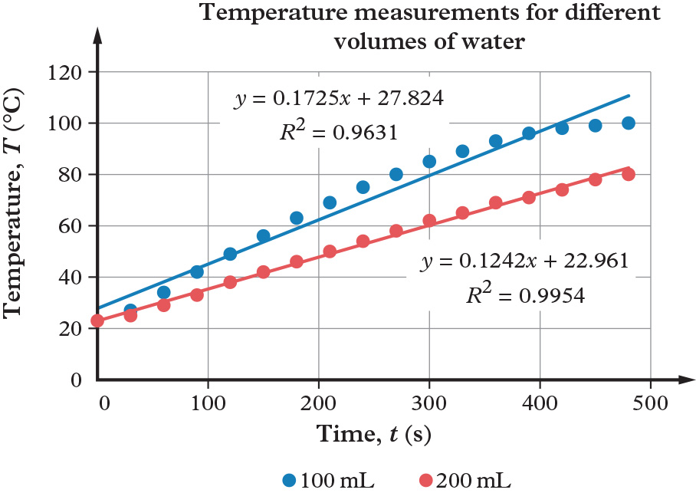

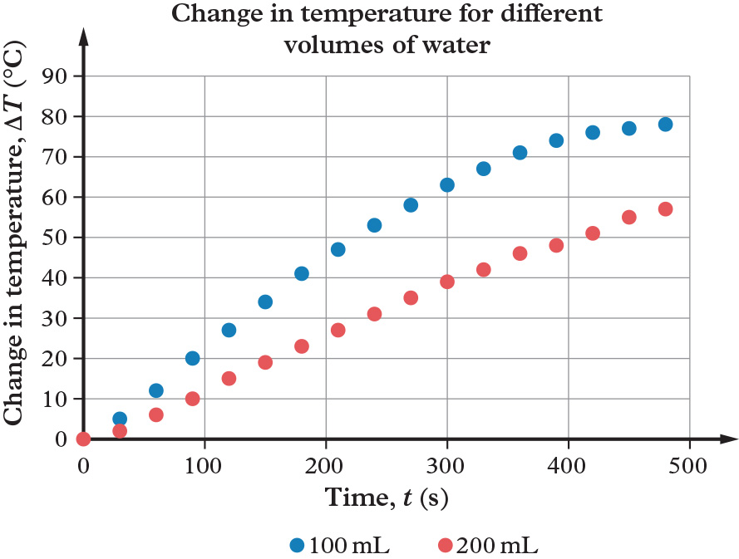

Experiment conducted on a hotplate with measurements taken every 30 seconds. Numbers will vary based on equipment used and environmental conditions R².
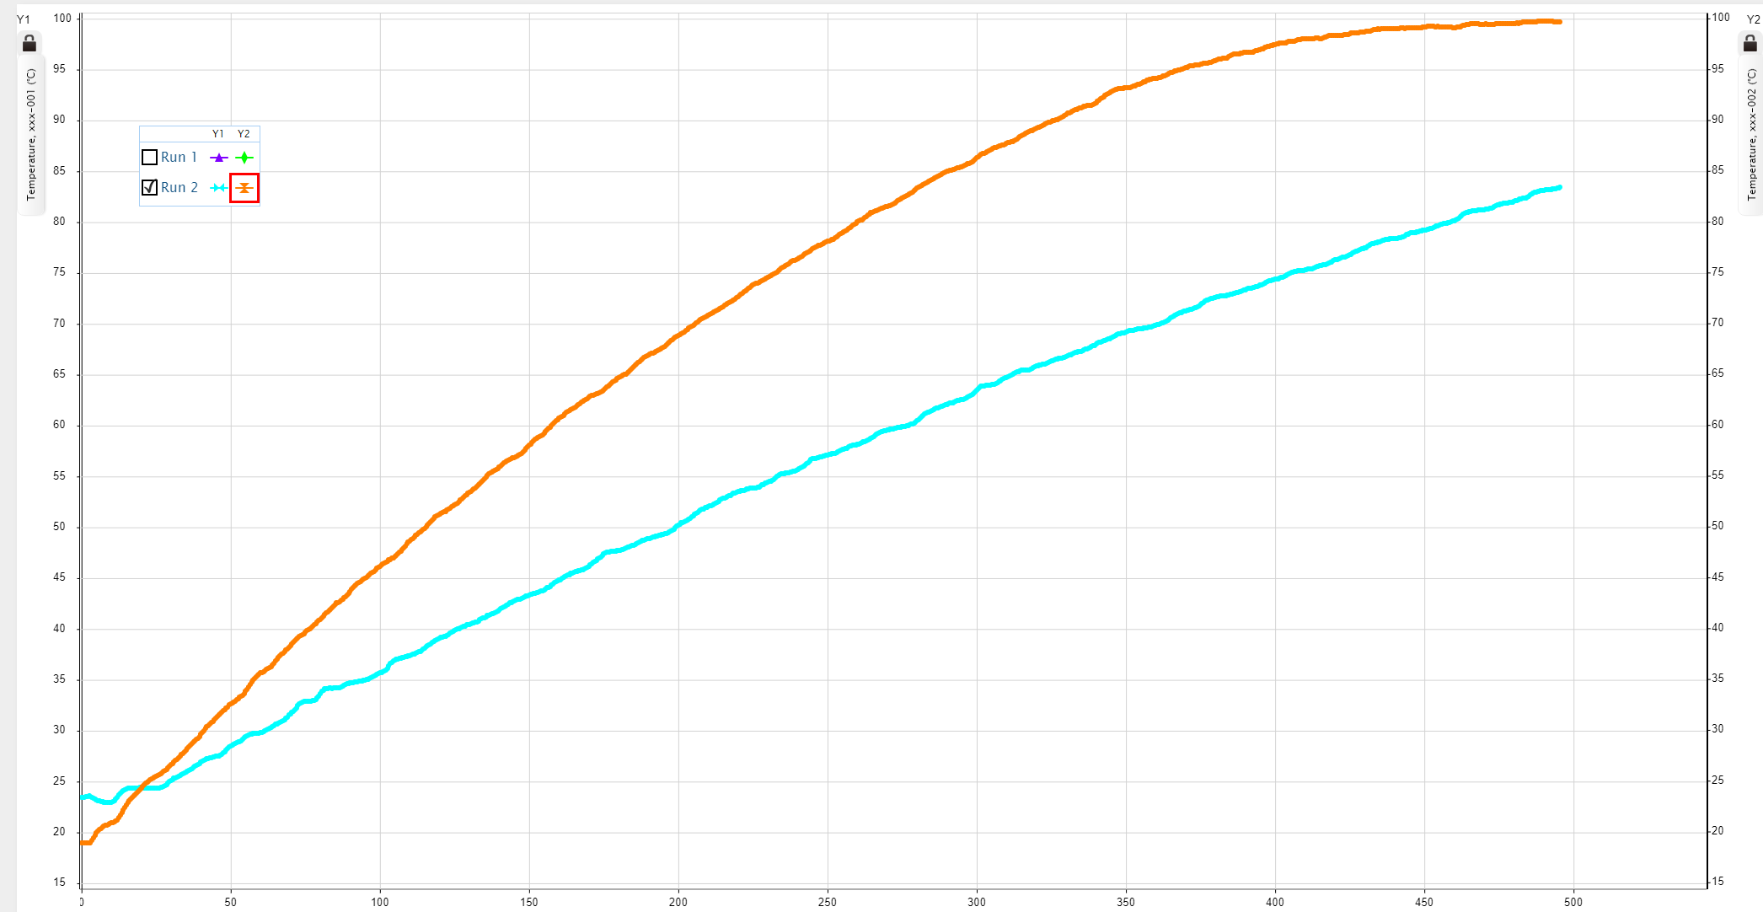
Same experiment settings as before, but instead two data loggers were run to collect the results. Thermometers and data loggers were both in the same liquid at the same time. Orange represents the 100 mL water in the above graph. The 200 mL thermometer went into the water a few seconds before the 100 mL one.

Starter activity: Practical overview
Approximate time: 5 minutes
Activity placement: Place directly above “Aim”
Activity summary: An overview of the purpose of the practical.

Notes for the teacher
- Read the aim out loud and relate it to the science understanding subject matter students have been learning about.

Instructions for students
- Think about what you will learn by doing this practical activity.

Practical: Method and safety discussion
Approximate time: 10 minutes
Activity placement: Place directly above “Method”
Activity summary: A run through of the practical method and discussion of any safety considerations.

Notes for the teacher
- Run through the method with students.
- Students should have reviewed the risk assessment as homework prior to this lesson. Ask them to identify the safety considerations. Prompt students until all considerations have been identified.
- Remind students of best practice to ensure safety in the laboratory or classroom.

Instructions for students
- Listen to your teacher run through the practical method.

Discussion questions
- What are the key safety considerations for this practical?
- What measures should you take to address them?
- What are the disposal methods for the materials you will be using?

Helpful hints
- Refer to this practical’s risk assessment to help you answer the questions.
Risk assessment

Answers
- Hot equipment and hot water.
- Not reaching over the top of equipment/water while in use. Wearing lab coat/apron to protect body. Wearing goggles to protect eyes.
- Using tongs to empty water into nearby sink at completion of practical.

Practical: Results discussion
Approximate time: 30 minutes
Activity placement: Place directly above “Discussion”
Activity summary: A class discussion about the results.

Notes for the teacher
- Instruct students to complete the discussion questions in their logbooks.
- During the last 5 minutes of class come together to discuss the results of the practical, including identification of errors, mistakes and anomalies, and clarification of any misconceptions.
- Assign any incomplete questions for homework.

Instructions for students
1. Answer the Results and Discussion questions in your logbook.
2. Consider your results and identify any suspected errors, mistakes and anomalies.
3. Discuss these with the rest of the class.

